Counting Semaphore
# Source: AI Source: Provided by: [Data Path: Persons Table -> ID Column: 1, Name_En Column: Motasem Essam] -> From: [ChatGPT] on [1/21/2026]
Counting Semaphore is a more advanced type of semaphore used in Real-Time Systems (RTS) to manage access to multiple instances of a shared resource. Unlike binary semaphores, it can represent more than one available resource.

Definition
# Source: AI Source: Provided by: [Data Path: Persons Table -> ID Column: 1, Name_En Column: Motasem Essam] -> From: [ChatGPT] on [1/21/2026]
A counting semaphore is a synchronization primitive that can take any non-negative integer value:
- The value represents the number of available instances of a resource.
- Tasks can acquire or release the resource using semaphore operations.

Key Features
# Source: AI Source: Provided by: [Data Path: Persons Table -> ID Column: 1, Name_En Column: Motasem Essam] -> From: [ChatGPT] on [1/21/2026]
- Tracks Multiple Resources: Can manage several identical resources simultaneously (e.g., printers, database connections).
- Atomic Operations:
  - Wait (P / down): Decreases the semaphore value; blocks task if value < 0.
  - Signal (V / up): Increases the semaphore value; wakes waiting tasks.
- Prevents Resource Conflicts: Ensures tasks do not exceed available resources.
- Used in Both Real-Time and Multithreaded Systems: Supports periodic and aperiodic tasks.

Example
# Source: AI Source: Provided by: [Data Path: Persons Table -> ID Column: 1, Name_En Column: Motasem Essam] -> From: [ChatGPT] on [1/21/2026]
Suppose a system has 3 identical printers and multiple tasks want to print:
- Counting semaphore initialized to 3 (all printers available)
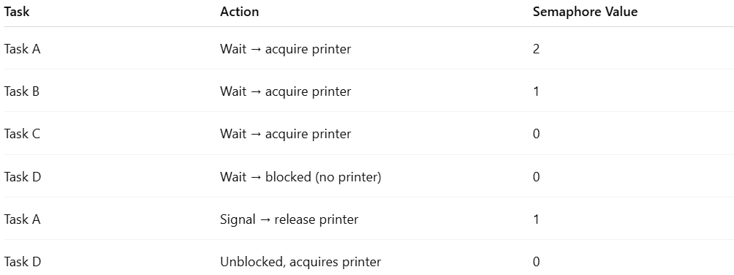
Task | Action | Semaphore Value
Task A | Wait → acquire printer | 2
Task B | Wait → acquire printer | 1
Task C | Wait → acquire printer | 0
Task D | Wait → blocked (no printer) | 0
Task A | Signal → release printer | 1
Task D | Unblocked, acquires printer | 0
- The counting semaphore tracks available printers, ensuring no two tasks use the same printer simultaneously.

Advantages
# Source: AI Source: Provided by: [Data Path: Persons Table -> ID Column: 1, Name_En Column: Motasem Essam] -> From: [ChatGPT] on [1/21/2026]
- Efficiently manages multiple identical resources.
- Prevents race conditions and over-allocation.
- Supports flexible task synchronization in real-time environments.

Disadvantages
# Source: AI Source: Provided by: [Data Path: Persons Table -> ID Column: 1, Name_En Column: Motasem Essam] -> From: [ChatGPT] on [1/21/2026]
- Slightly more complex than binary semaphores.
- Mismanagement can lead to deadlocks or resource starvation.
- Cannot enforce mutual exclusion on a single critical section (binary semaphore is better for that).

Why Counting Semaphores Matter for Software Engineers
# Source: AI Source: Provided by: [Data Path: Persons Table -> ID Column: 1, Name_En Column: Motasem Essam] -> From: [ChatGPT] on [1/21/2026]
- Useful for resource management in embedded systems, industrial automation, and networking.
- Helps design efficient real-time systems where multiple tasks share limited resources.
- Builds understanding of semaphores, synchronization, and concurrency control in RTOS.

